Create database using ubonto instance

Step-1: Creating VPC

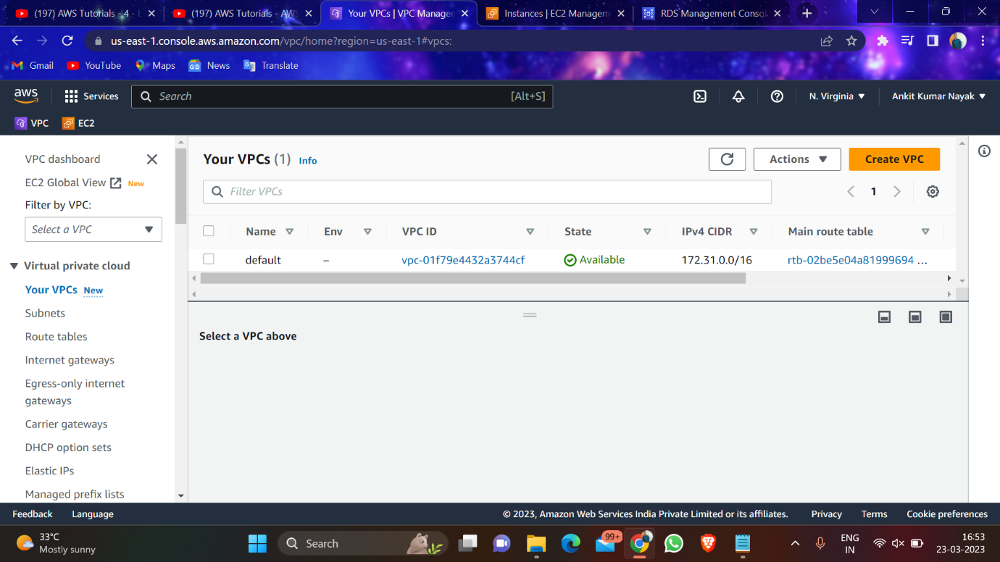

Step-2: Create Subnet

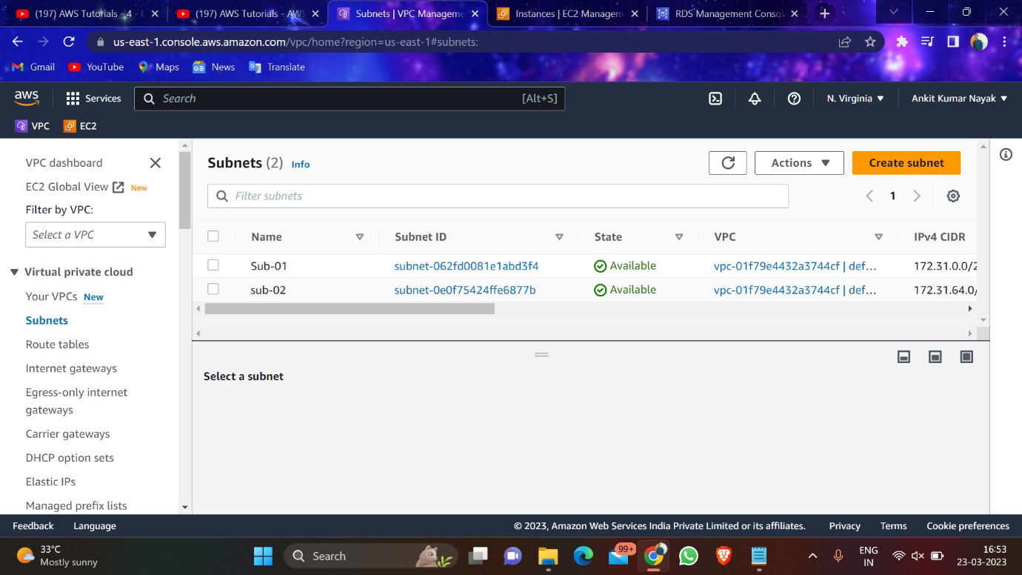

Step-3: Create Route Table

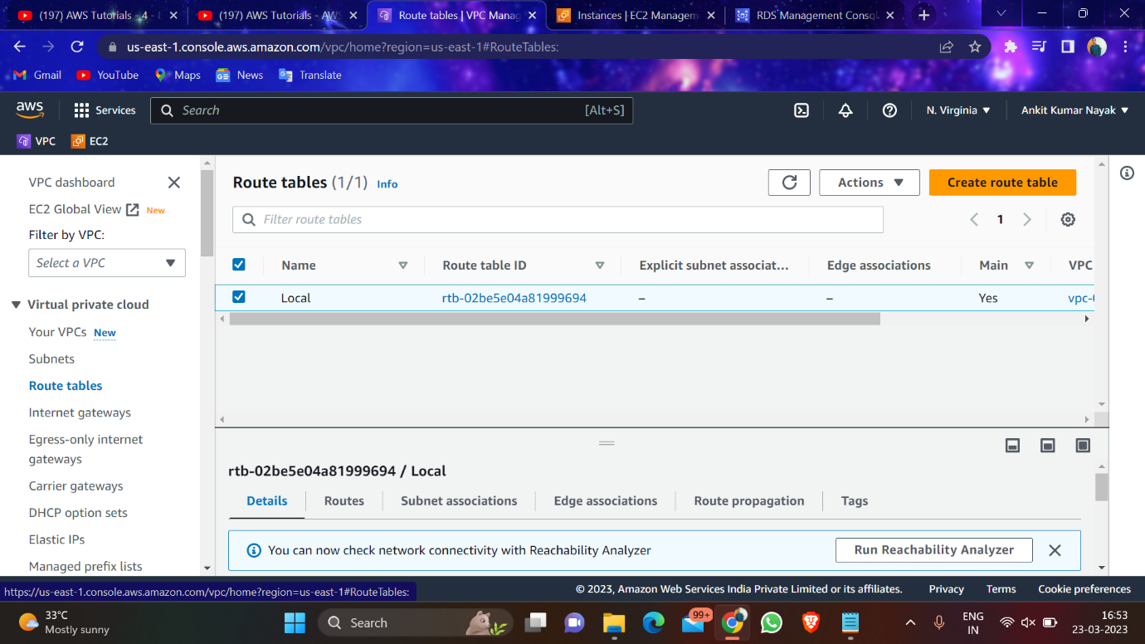

Step-4: Create Internet Gateway

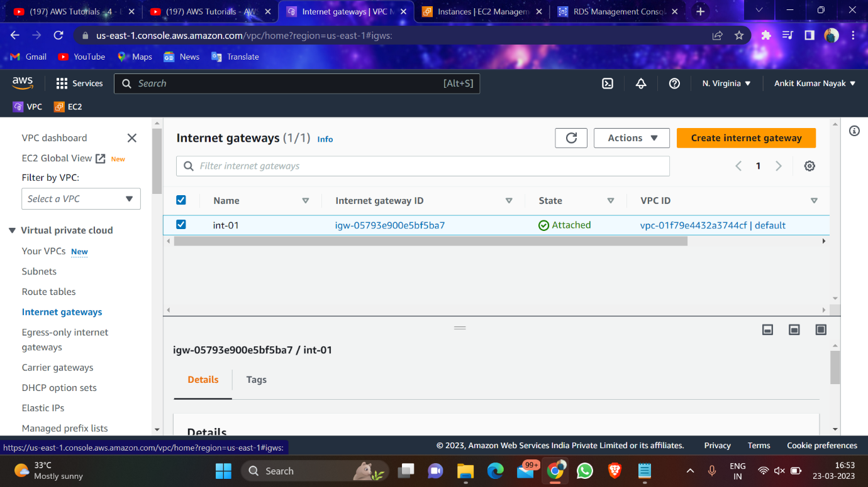

Step-5: Craete a instance using ubonto

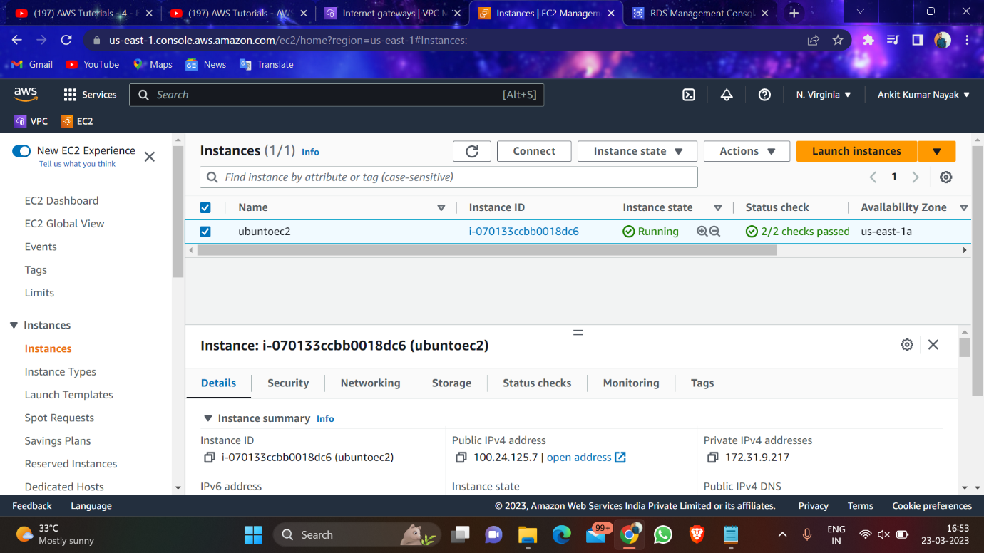

Step-6: Goto Amazon RDS🡪Create database

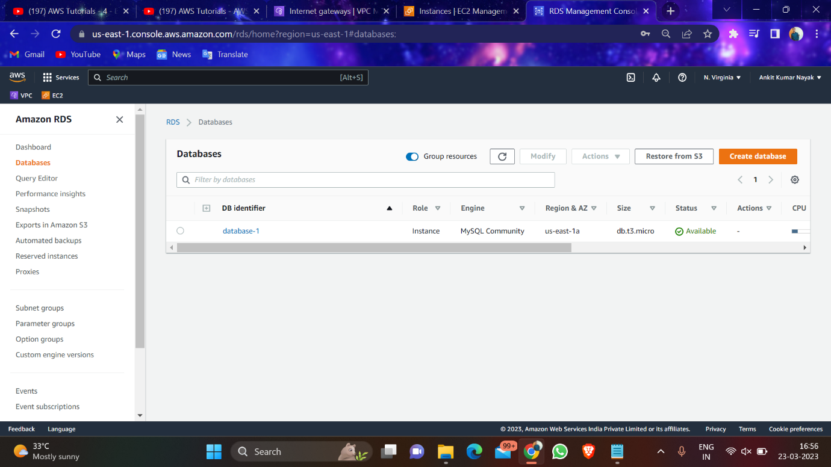

Step-7: Create on the database created🡪 Actions🡪 Setup EC2 Instance

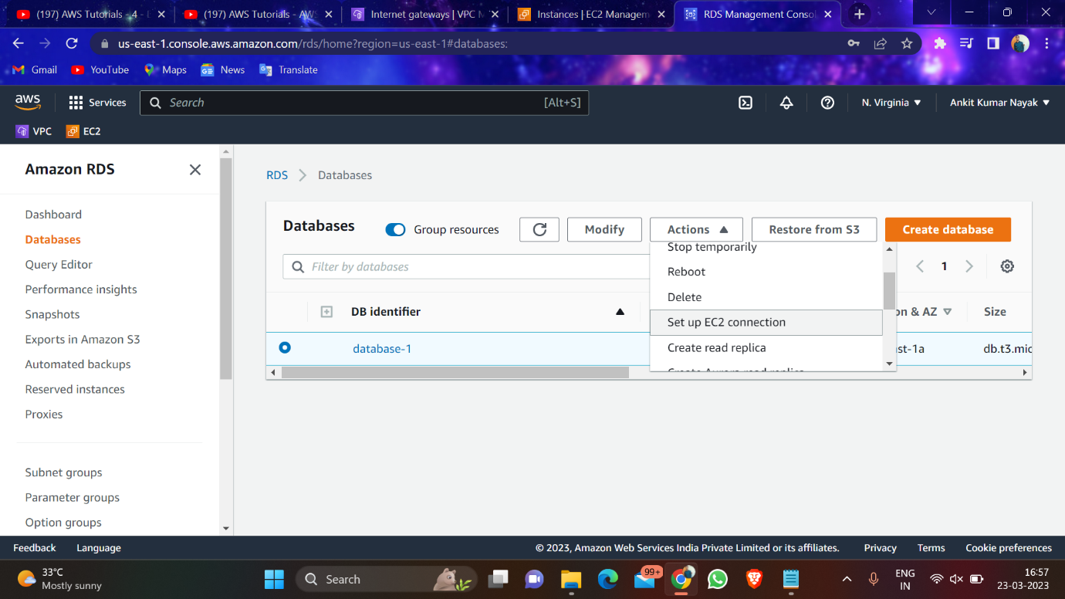

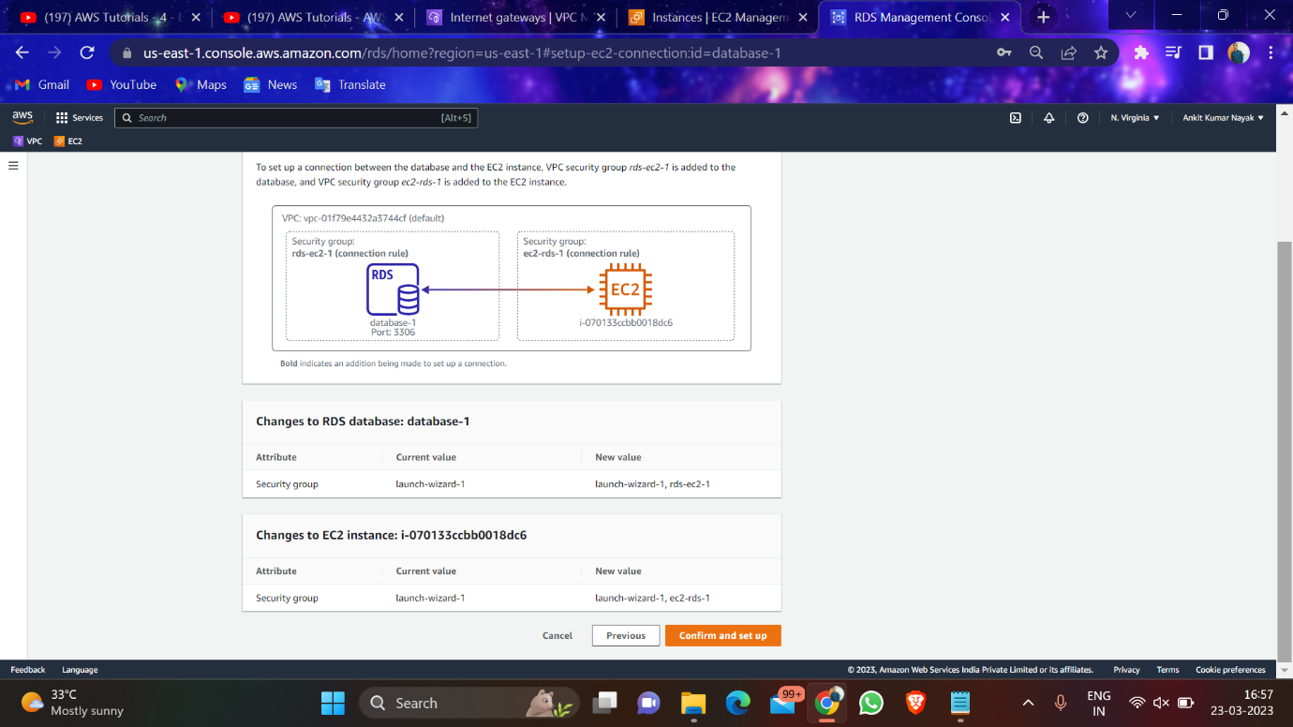

Step8: Change the security group of the instance which we have created

* Port range🡪 3306
* Source🡪 Copy private ip / give as anywhere

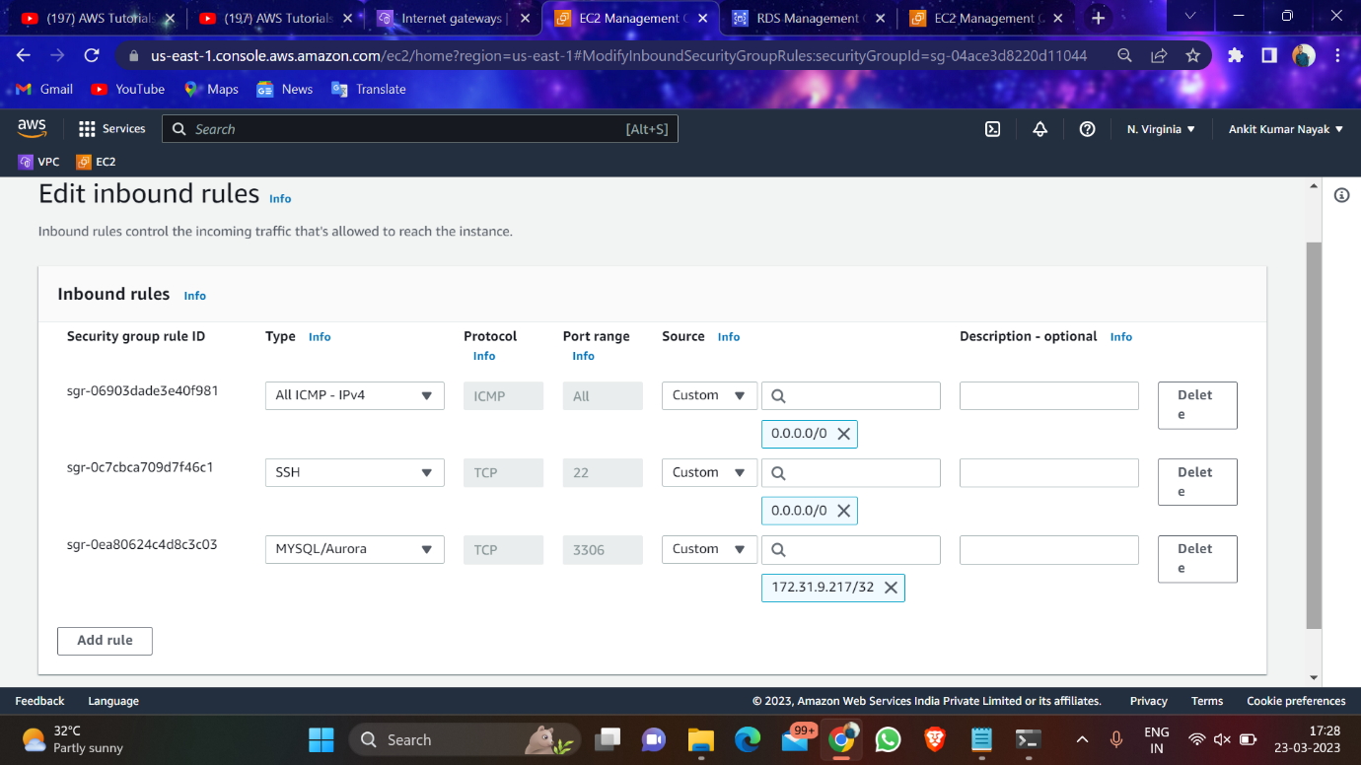

Step9: Run the Instance and follow the command

1. sudo apt-get install mysql-client -y
2. mysql -h database-1.<endpoint name> -P 3306 -u admin -p
3. then enter the password
4. CREATE DATABASE db1;
5. Use db1
6. Show tables
7. Insert into tb1 values (“ankit”), (“song”), (“dance”);
8. select \* from tb1;
9. insert into tb1 (name) values (“dev”), (“prod”);
10. select \* from tb1

